|  |
| --- |
|  |
| SOVY |
| Digital Calculator PO1_DGC_GDD |

|  |
| --- |
|  |

Table of Contents

1. Document Status 3

2. Document History 4

3. Reference Documents 5

4. Project Description 6

5. Software Context Diagram 6

6. Software features 7

7. Static Architecture 7

8. MCAL Component APIs 8

9. HAL Component APIs 14

10. App Component APIs 18

# Document Status

|  |  |
| --- | --- |
| Name | SOVY |
| Version | 1.3 |
| Status | Draft |
| Author | Nihal Khaled |
| Date | 6/4/2021 |

# Document History

|  |  |  |  |
| --- | --- | --- | --- |
| Version | Author | Date | Change |
| 1.0 | AAF | 3/4/2021 | Initial Creation. |
| 1.1 | Habiba Mahmoud | 5/4/2021 | Added APP Component APIs   * Req_PO1_DGC_GDD_0011-V1.0 * Req_PO1_DGC_GDD_0012-V1.0 * Req_PO1_DGC_GDD_0013-V1.0 * Req_PO1_DGC_GDD_0014-V1.0 |
| 1.2 | Anrdew Ezzat | 6/4/2021 | Added APP Component APIs   * Req_PO1_DGC_GDD_0015-V1.0 * Req_PO1_DGC_GDD_0016-V1.0 * Req_PO1_DGC_GDD_0017-V1.0 * Req_PO1_DGC_GDD_0018-V1.0 * Req_PO1_DGC_GDD_0019-V1.0 * Req_PO1_DGC_GDD_0020-V1.0 * Req_PO1_DGC_GDD_0021-V1.0 |
| 1.3 | Nihal khaled | 6/4/2021 | Software feature and Static diagrams are added |

# Reference Documents

|  |  |  |  |
| --- | --- | --- | --- |
| Ref. No. | Doc. Name | Version | Status |
| 1 | PO1_DGC_SRS_DigitalCalculator | 1.3 | proposed |

# Project Description

“Sovy” is a simple digital calculator that performs basic mathematical operations and displays the operation on an LCD-screen, with an ON/OFF button and keypad for user input.

# Software Context Diagram

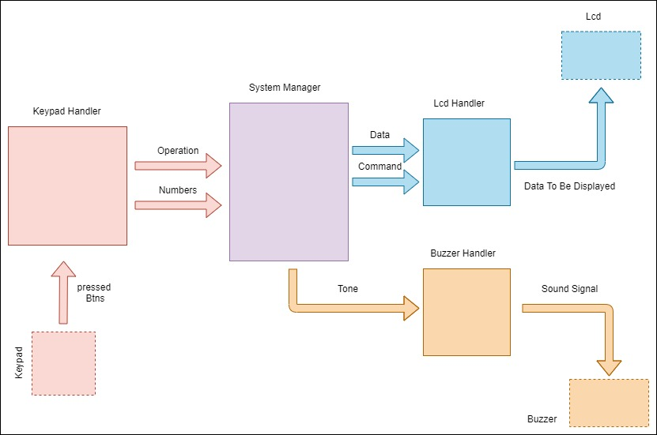

# 6. Software features

# 7.Static Architecture

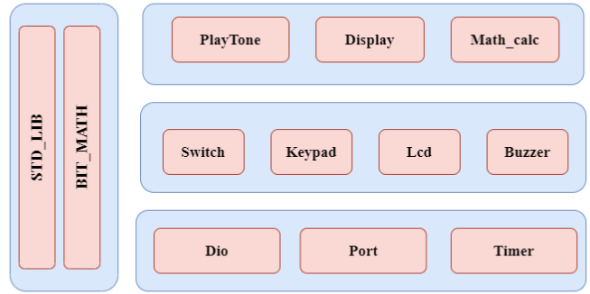

# 8. MCAL Component APIs

## Port:

|  |  |  |  |
| --- | --- | --- | --- |
| **Req_ID** | Req_PO1_DGC_GDD_001-V1.0 | | |
| **Component** | Port | | |
| **Return Type** | void | **Input arguments** | void |
| **Name** | **Port_vidInit** | | |
| **Description** | Initialize all pins and ports to their operation mode and initial values | | |
| **Covers** | -None | | |
| **Range** | - | | |

|  |  |  |  |  |
| --- | --- | --- | --- | --- |
| **Req_ID** | Req_PO1_DGC_GDD_002-V1.0 | | | |
| **Component** | Port | | | |
| **Return Type** | void | **Input arguments** | ***u8*** | Copy_u8SwPinNo |
| ***u8*** | Copy_u8PinMode |
| **Name** | **Port_vidSetPinMode** | | | |
| **Description** | This function is used to change the Software pin Mode | | | |
| **Covers** | -None | | | |
| **Range** | **-** Copy_u8SwPinNo**: {PORT_u8PIN_0 -> PORT_u8PIN_31}**  - Copy_u8PinMode**: {PORT_u8OUTPUT_LOW, PORT_u8OUTPUT_HIGH, PORT_u8INPUT_PULL_UP ,PORT_u8INPUT_HIGH_IMP}** | | | |

|  |  |  |  |  |
| --- | --- | --- | --- | --- |
| **Req_ID** | Req_PO1_DGC_GDD_003-V1.0 | | | |
| **Component** | Port | | | |
| **Return Type** | void | **Input arguments** | ***u8*** | Copy_u8SwPinNo |
| ***u8*** | Copy_u8SwPinDir |
| **Name** | **Port_vidSetPinDir** | | | |
| **Description** | This function is used to change the Software pin direction | | | |
| **Covers** | -None | | | |
| **Range** | **-** Copy_u8SwPinNo**: {PORT_u8PIN_0 -> PORT_u8PIN_31}**  - Copy_ u8SwPinDir**: {Port_u8INPUT,Port_u8OUTPUT}** | | | |

## Dio

|  |  |  |  |  |
| --- | --- | --- | --- | --- |
| **Req_ID** | Req_PO1_DGC_GDD_004-V1.0 | | | |
| **Component** | Dio | | | |
| **Return Type** | u8 | **Input arguments** | ***u8*** | Copy_u8SwPinNo |
| ***u8*** | Copy_u8SwPinVal |
| **Name** | **Dio_u8SetPinVal** | | | |
| **Description** | This function is used to change the Software pin Value | | | |
| **Covers** | -None | | | |
| **Range** | **-** Copy_u8SwPinNo**: {PORT_u8PIN_0 -> PORT_u8PIN_31}**  - Copy_ u8SwPinVal**: {DIO_u8HIGH, DIO_u8LOW}** | | | |

|  |  |  |  |  |
| --- | --- | --- | --- | --- |
| **Req_ID** | Req_PO1_DGC_GDD_005-V1.0 | | | |
| **Component** | Dio | | | |
| **Return Type** | u8 | **Input arguments** | ***u8*** | Copy_u8SwPinNo |
| **Name** | **Dio_u8GetPinVal** | | | |
| **Description** | This function is used to get the Software pin Value | | | |
| **Covers** | -None | | | |
| **Range** | **-** Copy_u8SwPinNo**: {PORT_u8PIN_0 -> PORT_u8PIN_31}**  **-** returnrange **: {DIO_u8HIGH, DIO_u8LOW}** | | | |

## Timer

|  |  |  |  |
| --- | --- | --- | --- |
| **Req_ID** | Req_PO1_DGC_GDD_006-V1.0 | | |
| **Component** | Timer | | |
| **Return Type** | Void | **Input arguments** | Void |
| **Name** | **Gpt_vidInit** | | |
| **Description** | This function is used to initialize the Timer | | |
| **Covers** | -None | | |
| **Range** | **-** None | | |

|  |  |  |  |
| --- | --- | --- | --- |
| **Req_ID** | Req_PO1_DGC_GDD_007-V1.0 | | |
| **Component** | Timer | | |
| **Return Type** | Void | **Input arguments** | Void |
| **Name** | **Gpt_vidStartTimer** | | |
| **Description** | This function is used to start the Timer | | |
| **Covers** | -None | | |
| **Range** | **-** None | | |

|  |  |  |  |
| --- | --- | --- | --- |
| **Req_ID** | Req_PO1_DGC_GDD_008-V1.0 | | |
| **Component** | Timer | | |
| **Return Type** | Void | **Input arguments** | Void |
| **Name** | **Gpt_vidStopTimer** | | |
| **Description** | This function is used to stop the Timer | | |
| **Covers** | -None | | |
| **Range** | **-** None | | |

|  |  |  |  |
| --- | --- | --- | --- |
| **Req_ID** | Req_PO1_DGC_GDD_009-V1.0 | | |
| **Component** | Timer | | |
| **Return Type** | Void | **Input arguments** | Void (*pfun)(void) |
| **Name** | **Gpt_vidSetCBF** | | |
| **Description** | This function is used to set the call back function of the Timer | | |
| **Covers** | -None | | |
| **Range** | **-** None | | |

|  |  |  |  |  |
| --- | --- | --- | --- | --- |
| **Req_ID** | Req_PO1_DGC_GDD_0010-V1.0 | | | |
| **Component** | Timer | | | |
| **Return Type** | Void | **Input arguments** | ***u8*** | Copy_u8LoadVal |
| **Name** | **Gpt_vidLoadTimer** | | | |
| **Description** | This function is used to load the timer with a value to start counting from it | | | |
| **Covers** | -None | | | |
| **Range** | **-** Copy_u8LoadVal : {0 -> 255 } | | | |

## 

## 9. HAL Component APIs

## Switch Component:

|  |  |  |  |  |  |
| --- | --- | --- | --- | --- | --- |
| **Req_ID** | Req_PO1_DGC_GDD_0015-V1.0 | | **Covers** |  | Req_1ST123_SRS_overall_001-V1.1  Req_1ST123_SRS_overall_002-V1.0  Req_1ST123_SRS_overall_003-V1.1  Req_1ST123_SRS_overall_004-V1.1  Req_1ST123_SRS_overall_005-V1.1  Req_1ST123_SRS_overall_006-V1.1  Req_1ST123_SRS_overall_007-V1.0  Req_1ST123_SRS_overall_008-V1.0  Req_1ST123_SRS_overall_009-V1.1 |
| **Description:** | Get Switch state according to its config file that it configures its Port and pin to get its status | | | | |
| **API** | ReturnStatus_e Switch_GetState (u8 Copy_u8SwId, pu8 Copy_ptrState) | | | | |
| **Parameters** | **Type** | **Name** | | | **Description** |
| u8  pu8 | Copy_u8SwId  Copy_ptrState | | | Switch ID to get state of a certain switch  Pointer to state of the switch according to Switch_config file  Pressed will represent 0 or 1  If RELEASE_STATE defined as 1  So pressed will represent 0  If RELEASE_STATE defined as 0  So pressed will represent 1 |
| **Return** | **Type** | **Name** | | | **Description** |
| ReturnStatus_e | _____ | | | STD_ERORR  E_OK -> If the SwNum sent is in the scope  E_NOK -> If SwNum sent is out of the scope |

# 2. Buzzer Component:

|  |  |  |  |  |  |
| --- | --- | --- | --- | --- | --- |
| **Req_ID** | Req_PO1_DGC_GDD_0016-V1.0 | | **Covers** |  | Req_1ST123_SRS_overall_026-V1.0 |
| **Description:** | It sets buzzer state according to its config file that it congiures its port and pin make sound when button is pressed. | | | | |
| **API** | ReturnStatus_e Buzzer_SetState(u8 State) | | | | |
| **Parameters** | **Type** | **Name** | | | **Description** |
| u8 | State | | | Buzzer state to set its pin to this state  High -> 1  Low -> 0 |
| **Return** | **Type** | **Name** | | | **Description** |
| ReturnStatus_e | _____ | | | STD_ERORR  E_OK -> If State Sent is 0 or 1  E_NOK -> If State send is not 0 nor 1 |

# 3. LCD Component:

|  |  |  |  |  |  |
| --- | --- | --- | --- | --- | --- |
| **Req_ID** | Req_PO1_DGC_GDD_0017-V1.0 | | **Covers** |  | Req_1ST123_SRS_overall_013-V1.0 |
| **Description:** | It initializing the Lcd by init sequence and the configuration of pins. | | | | |
| **API** | ReturnStatus_e Lcd_Init(void) | | | | |
| **Parameters** | **Type** | **Name** | | | **Description** |
| void | _____ | | | _____ |
| **Return** | **Type** | **Name** | | | **Description** |
| ReturnStatus_e | _____ | | | STD_ERORR  E_OK -> If the function cleared the LCD successfully  E_NOK -> If any problem occurred while clearing the LCD |

|  |  |  |  |  |  |
| --- | --- | --- | --- | --- | --- |
| **Req_ID** | Req_PO1_DGC_GDD_0018-V1.0 | | **Covers** |  | Req_1ST123_SRS_overall_025-V1.0 |
| **Description:** | It clears the screen. | | | | |
| **API** | ReturnStatus_e Lcd_Clear(void) | | | | |
| **Parameters** | **Type** | **Name** | | | **Description** |
| void | _____ | | | _____ |
| **Return** | **Type** | **Name** | | | **Description** |
| ReturnStatus_e | _____ | | | STD_ERORR  E_OK -> If the function cleared the LCD successfully  E_NOK -> If any problem occurred while clearing the LCD |

|  |  |  |  |  |  |
| --- | --- | --- | --- | --- | --- |
| **Req_ID** | Req_PO1_DGC_GDD_0019-V1.0 | | **Covers** |  | Req_1ST123_SRS_overall_022-V1.0  Req_1ST123_SRS_overall_021-V1.0  Req_1ST123_SRS_overall_014-V1.0  Req_1ST123_SRS_overall_015-V1.0  Req_1ST123_SRS_overall_016-V1.0  Req_1ST123_SRS_overall_017-V1.0  Req_1ST123_SRS_overall_018-V1.0  Req_1ST123_SRS_overall_019-V1.0  Req_1ST123_SRS_overall_012-V1.1  Req_1ST123_SRS_overall_011-V1.1 |
| **Description:** | It takes Pointer to char of the string that it will be written as whole onto the LCD. | | | | |
| **API** | ReturnStatus_e Lcd_WriteString(pu8 Copy_ptrString); | | | | |
| **Parameters** | **Type** | **Name** | | | **Description** |
| pu8 | Copy_ptrString | | | Pointer to char of the string to be written onto LCD |
| **Return** | **Type** | **Name** | | | **Description** |
| ReturnStatus_e | _____ | | | STD_ERORR  E_OK -> If sent character pattern valid in the CGROM  E_NOK -> If a pattern sent outside the scope of the CGROM |

|  |  |  |  |  |  |
| --- | --- | --- | --- | --- | --- |
| **Req_ID** | Req_PO1_DGC_GDD_0020-V1.0 | | **Covers** |  | Req_1ST123_SRS_overall_019-V1.0 |
| **Description:** | It sets new position for the LCD to start write from.  XPos -> which column  YPos -> which Row  To select which cell. | | | | |
| **API** | ReturnStatus_e Lcd_GotoXY(u8 Copy_u8XPos, u8 Copy_u8YPos) | | | | |
| **Parameters** | **Type** | **Name** | | | **Description** |
| u8  u8 | Copy_u8XPos  Copy_u8YPos | | | XPos -> which column  YPos -> which row |
| **Return** | **Type** | **Name** | | | **Description** |
| ReturnStatus_e | _____ | | | STD_ERORR  E_OK -> If XPos is sent between 0-15 and YPos is sent between 0-1  E_NOK -> If any other range is sent either in XPos or YPos |

|  |  |  |  |  |  |
| --- | --- | --- | --- | --- | --- |
| Req_ID | Req_PO1_DGC_GDD_0021-V1.0 | | **Covers** |  | Req_1ST123_SRS_overall_020-V1.0 |
| Description: | It writes number onto the LCD. | | | | |
| API | ReturnStatus_e Lcd_WriteNum (u16 Copy_u16Num); | | | | |
| Parameters | **Type** | **Name** | | | **Description** |
| U16 | Copy_u16Num | | | Number to be written onto the LCD |
| Return | **Type** | **Name** | | | **Description** |
| ReturnStatus_e | _____ | | | STD_ERORR  E_OK -> If Numbers between 0-9 are sent  E_NOK -> If anything except 0-9 is sent to the function |
|  |  |  | | |  |
|  |  |  | | |  |

# App Component APIs

|  |  |  |  |
| --- | --- | --- | --- |
| **Req_ID** | Req_PO1_DGC_GDD_0011-V1.0 | | |
| **Component** | Math_calc | | |
| **Return Type** | ReturnStatus_e | **Input arguments** | f32* Copy_f32Result |
| **Name** | DGC_CalcResult | | |
| **Description** | Calculate the operation and output the result and handle the corner cases. | | |
| **Covers** | -Req_1ST123_SRS_overall_003-V1.1  -Req_1ST123_SRS_overall_004-V1.1  -Req_1ST123_SRS_overall_005-V1.1  -Req_1ST123_SRS_overall_006-V1.1  -Req_1ST123_SRS_overall_008-V1.0  -Req_1ST123_SRS_overall_009-V1.1  -Req_1ST123_SRS_overall_010-V1.1  -Req_1ST123_SRS_overall_011-V1.1  -Req_1ST123_SRS_overall_012-V1.1 | | |
| **Range** | Copy_f32Result: (Float range)  ReturnStatus_e: (OK, NOK) | | |

|  |  |  |  |
| --- | --- | --- | --- |
| **Req_ID** | Req_PO1_DGC_GDD_0012-V1.0 | | |
| **Component** | Display | | |
| **Return Type** | ReturnStatus_e | **Input arguments** | u8 Copy_u8Char |
| **Name** | DGC_DisplayChar | | |
| **Description** | Display a character on the LCD screen | | |
| **Covers** | -Req_1ST123_SRS_overall_014-V1.0  -Req_1ST123_SRS_overall_015-V1.0  -Req_1ST123_SRS_overall_016-V1.0  -Req_1ST123_SRS_overall_017-V1.0  -Req_1ST123_SRS_overall_018-V1.0  -Req_1ST123_SRS_overall_019-V1.0  -Req_1ST123_SRS_overall_020-V1.0 | | |
| **Range** | Copy_u8Char: ([0:9],+,-,*,/,=)  ReturnStatus_e: (OK, NOK) | | |

|  |  |  |  |
| --- | --- | --- | --- |
| **Req_ID** | Req_PO1_DGC_GDD_0013-V1.0 | | |
| **Component** | Display | | |
| **Return Type** | ReturnStatus_e | **Input arguments** | u8 Copy_kpau8Str |
| **Name** | DGC_DisplayError | | |
| **Description** | Display error message when needed | | |
| **Covers** | -Req_1ST123_SRS_overall_021-V1.0  -Req_1ST123_SRS_overall_022-V1.0 | | |
| **Range** | Copy_kpau8Str: (“Syntax Error”,” Math Error”)  ReturnStatus_e: (OK, NOK) | | |

|  |  |  |  |
| --- | --- | --- | --- |
| **Req_ID** | Req_PO1_DGC_GDD_0014-V1.0 | | |
| **Component** | PlayTone | | |
| **Return Type** | ReturnStatus_e | **Input arguments** | void |
| **Name** | DGC_PlayTone | | |
| **Description** | Plays a tone when a key is pressed on the keypad | | |
| **Covers** | -Req_1ST123_SRS_overall_026-V1.0 | | |
| **Range** | ReturnStatus_e: (OK, NOK) | | |